Practice-6.2:

Code:

Syntax error:

int number = 10 // Missing semicolon

logic error:

int a = 5;

int b = 3;

int result = a - b; // Intended to add, but used subtraction

exception:

int[] arr = new int[5];

int value = arr[10]; // ArrayIndexOutOfBoundsException

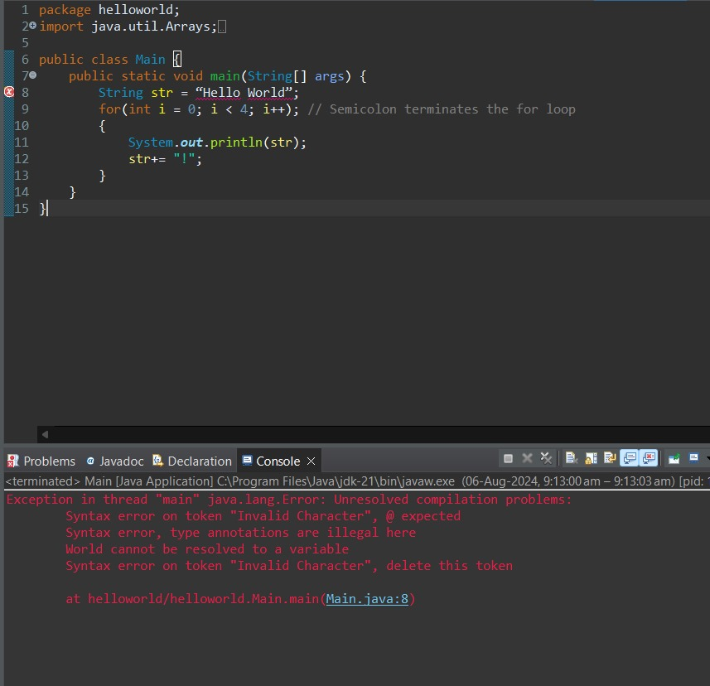

1. **Describe an exception that you have experienced in your program before. Explain how it could be handled with a try/catch block of code.**

Code:

int[] arr = new int[5];

System.out.println(arr[10]); // ArrayIndexOutOfBoundsException

1. **Write a segment of code that has:**

**a. A syntax error**

**b. A logic error**

**c. An exception**

syntax error:

int number = 10; // Missing semicolon

logic error:

int a = 5;

int b = 3;

int result = a - b; // Intended to add, but used subtraction

exeption:

int[] arr = new int[5];

System.out.println(arr[10]); // ArrayIndexOutOfBoundsException

1. **What is the difference between a checked exception and an unchecked exception?**

**Code:**

Checked exeption:

try {

FileReader file = new FileReader("somefile.txt");

} catch (FileNotFoundException e) {

e.printStackTrace();

}

Unchecked exeption:

String str = null;

System.out.println(str.length()); // NullPointerException